**List of Pandas Exercises:**

**Pandas Basics**

* [Pandas Data Series [ 40 exercises with solution ]](https://www.w3resource.com/python-exercises/pandas/index-data-series.php)
* **1.** Write a Pandas program to create and display a one-dimensional array-like object containing an array of data using Pandas module.

* **2.** Write a Pandas program to convert a Panda module Series to Python list and it's typeA screenshot of a computer program

  AI-generated content may be incorrect.
* **3.** Write a Pandas program to add, subtract, multiple and divide two Pandas Series.  
  Sample Series: [2, 4, 6, 8, 10], [1, 3, 5, 7, 9]  
  A screenshot of a computer

  AI-generated content may be incorrect.
* **4.** Write a Pandas program to compare the elements of the two Pandas Series.  
  Sample Series: [2, 4, 6, 8, 10], [1, 3, 5, 7, 10]  
  A screenshot of a computer

  AI-generated content may be incorrect.**5.** Write a Pandas program to convert a dictionary to a Pandas series.

* **6.** Write a Pandas program to convert a NumPy array to a Pandas series.

* **7.** Write a Pandas program to change the data type of given a column or a Series.

* **8.** Write a Pandas program to convert the first column of a DataFrame as a Series.

**9.** Write a Pandas program to convert a given Series to an array.\

**10.** Write a Pandas program to convert Series of lists to one Series.

**11.** Write a Pandas program to sort a given Series.

**12.** Write a Pandas program to add some data to an existing Series.

**13.** Write a Pandas program to create a subset of a given series based on value and condition.

**14.** Write a Pandas program to change the order of index of a given series.

**15.** Write a Pandas program to create the mean and standard deviation of the data of a given Series.

**16.** Write a Pandas program to get the items of a given series not present in another given series.

**17.** Write a Pandas program to get the items which are not common of two given series.

**18.** Write a Pandas program to compute the minimum, 25th percentile, median, 75th, and maximum of a given series.

**19.** Write a Pandas program to calculate the frequency counts of each unique value of a given series.

**20.** Write a Pandas program to display most frequent value in a given series and replace everything else as 'Other' in the series.

**21.** Write a Pandas program to find the positions of numbers that are multiples of 5 of a given series.

**22.** Write a Pandas program to extract items at given positions of a given series.

**23.** Write a Pandas program to get the positions of items of a given series in another given series.

**24.** Write a Pandas program convert the first and last character of each word to upper case in each word of a given series.

**25.** Write a Pandas program to calculate the number of characters in each word in a given series.

**26.** Write a [Pandas](https://www.w3resource.com/python-exercises/pandas/index-data-series.php) program to compute difference of differences between consecutive numbers of a given series.

**27.** Write a Pandas program to convert a series of date strings to a timeseries.

**28.** Write a Pandas program to get the day of month, day of year, week number and day of week from a given series of date strings.

**29.** Write a Pandas program to convert year-month string to dates adding a specified day of the month.

**30.** Write a Pandas program to filter words from a given series that contain atleast two vowels.

**31.** Write a Pandas program to compute the Euclidean distance between two given series.  
Euclidean distance  
From Wikipedia,  
In mathematics, the Euclidean distance or Euclidean metric is the "ordinary" straight-line distance between two points in Euclidean space. With this distance, Euclidean space becomes a metric space. The associated norm is called the Euclidean norm.

**32.** Write a Pandas program to find the positions of the values neighboured by smaller values on both sides in a given series.

**33.** Write a Pandas program to replace missing white spaces in a given string with the least frequent character.

**34.** Write a Pandas program to compute the autocorrelations of a given numeric series.  
From Wikipedia:  
Autocorrelation, also known as serial correlation, is the correlation of a signal with a delayed copy of itself as a function of delay. Informally, it is the similarity between observations as a function of the time lag between them.

**35.** Write a Pandas program to create a TimeSeries to display all the Sundays of given year.

**36.** Write a Pandas program to convert given series into a dataframe with its index as another column on the dataframe.

**37.** Write a Pandas program to stack two given series vertically and horizontally.

**38.** Write a Pandas program to check the equality of two given series.

**39.** Write a Pandas program to find the index of the first occurrence of the smallest and largest value of a given series.

**40.** Write a Pandas program to check inequality over the index axis of a given dataframe and a given series.

* [Pandas DataFrame [ 81 exercises with solution ]](https://www.w3resource.com/python-exercises/pandas/index-dataframe.php)
* **1.**Write a Pandas program to create a dataframe from a dictionary and display it.

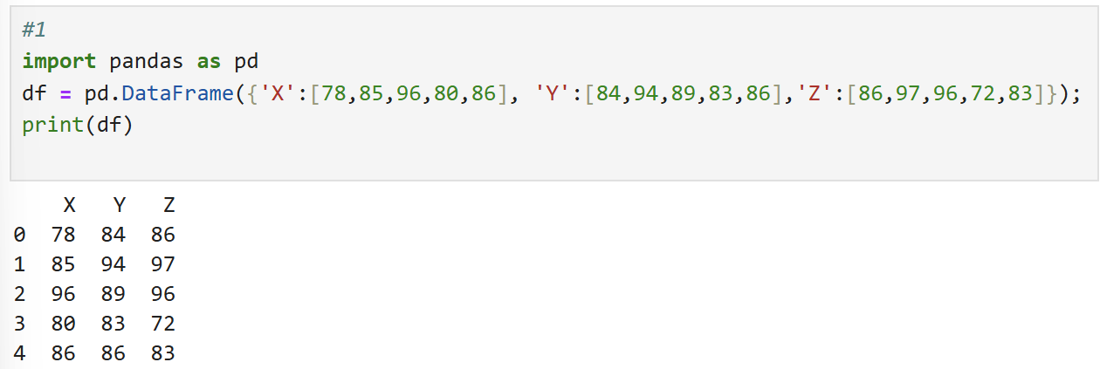

* **2.** Write a Pandas program to create and display a DataFrame from a specified dictionary data which has the index labels.A screenshot of a computer

  AI-generated content may be incorrect.
* **3.** Write a Pandas program to display a summary of the basic information about a specified DataFrame and its data.

* **4.** Write a Pandas program to get the first 3 rows of a given DataFrame.

* **5.** Write a Pandas program to select the 'name' and 'score' columns from the following DataFrame.

* **6.** Write a Pandas program to select the specified columns and rows from a given data frame.

* **7.** Write a Pandas program to select the rows where the number of attempts in the examination is greater than 2.

* **8.** Write a [Pandas](https://www.w3resource.com/python-exercises/pandas/index-dataframe.php) program to count the number of rows and columns of a DataFrame.

* **9.** Write a Pandas program to select the rows where the score is missing, i.e. is NaN.

* **10.** Write a Pandas program to select the rows the score is between 15 and 20 (inclusive).

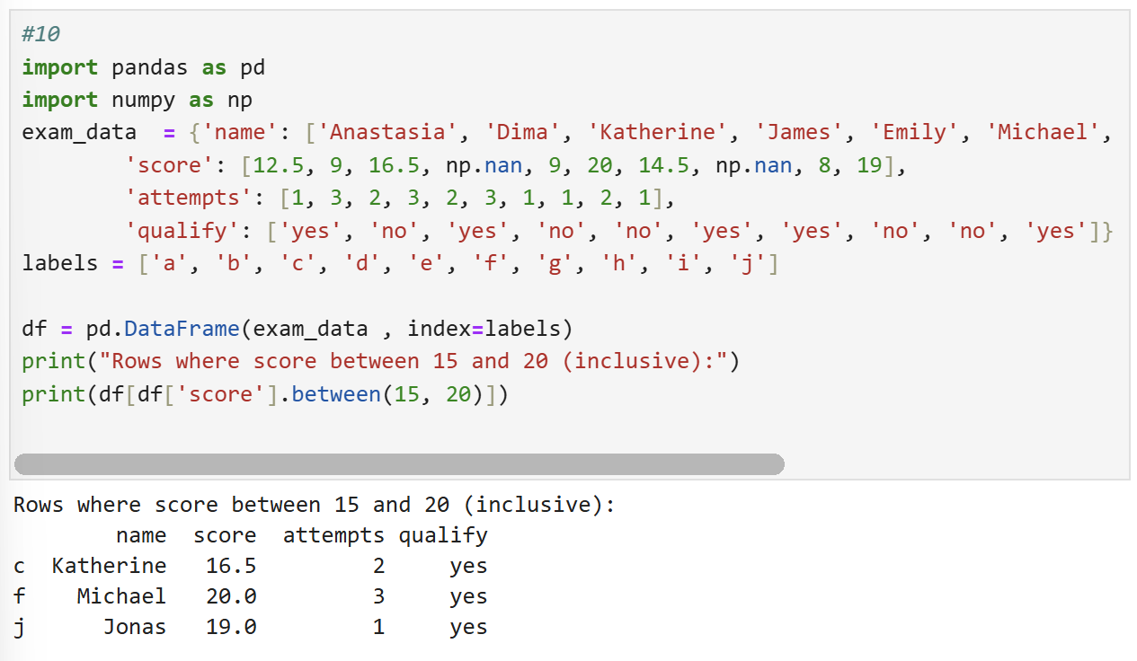

* **11.** Write a Pandas program to select the rows where number of attempts in the examination is less than 2 and score greater than 15.

* **12.** Write a Pandas program to change the score in row 'd' to 11.5.

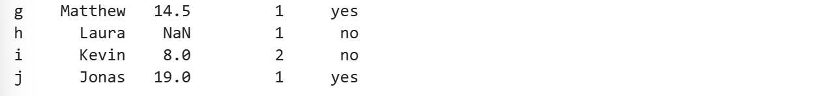

* **13.** Write a Pandas program to calculate the sum of the examination attempts by the students.

* **14.** Write a [Pandas](https://www.w3resource.com/python-exercises/pandas/index-dataframe.php) program to calculate the mean of all students' scores. Data is stored in a dataframe.

* **15.** Write a Pandas program to append a new row 'k' to data frame with given values for each column. Now delete the new row and return the original DataFrame.
* [Pandas Index [ 26 exercises with solution ]](https://www.w3resource.com/python-exercises/pandas/index/index.php)

**Pandas Advanced Indexing, Slicing, and Filtering**

* [Pandas Advanced Indexing and Slicing [ 15 exercises with solution ]](https://www.w3resource.com/python-exercises/pandas/pandas-advanced-indexing-and-slicing.php)
* [Pandas Filter [ 27 exercises with solution ]](https://www.w3resource.com/python-exercises/pandas/filter/index.php)

**Pandas Merging, Joining, and Grouping**

* [Pandas Joining and merging DataFrames [ 15 exercises with solution ]](https://www.w3resource.com/python-exercises/pandas/joining-and-merging/index.php)
* [Pandas Advanced Merging and Joining [ 20 exercises with solution ]](https://www.w3resource.com/python-exercises/pandas/pandas-advanced-merging-and-joining.php)
* [Pandas Grouping and Aggregating [ 32 exercises with solution ]](https://www.w3resource.com/python-exercises/pandas/groupby/index.php)
* [Pandas Advanced Grouping and Aggregation [ 15 exercises with solution ]](https://www.w3resource.com/python-exercises/pandas/advanced-grouping-and-aggregation/index.php)

**Pandas String and Text Operations**

* [Pandas String and Regular Expression [ 41 exercises with solution ]](https://www.w3resource.com/python-exercises/pandas/string/index.php)

**Pandas Time Series and Date Handling**

* [Pandas Time Series [ 20 exercises with solution ]](https://www.w3resource.com/python-exercises/pandas/time-series/index.php)
* [Pandas Datetime [ 25 exercises with solution ]](https://www.w3resource.com/python-exercises/pandas/datetime/index.php)
* [Pandas Resampling and Frequency Conversion [ 15 exercises with solution ]](https://www.w3resource.com/python-exercises/pandas/resampling-frequency-conversion/index.php)

**Pandas Handling Missing Data and Cleaning**

* [Pandas Handling Missing Values [ 20 exercises with solution ]](https://www.w3resource.com/python-exercises/pandas/missing-values/index.php)
* [Pandas Data Cleaning and Preprocessing [ 15 exercises with solution ]](https://www.w3resource.com/python-exercises/pandas/pandas-data-cleaning-and-preprocessing.php)

**Pandas Data Manipulation and Pivoting**

* [Pandas Pivot Table [ 32 exercises with solution ]](https://www.w3resource.com/python-exercises/pandas/excel/index-pivot.php)
* [Pandas Custom Function [ 20 exercises with solution ]](https://www.w3resource.com/python-exercises/pandas/pandas-custom-functions-and-apply-exercises.php)

**Pandas Data Validation and Performance Optimization**

* [Pandas Data Validation [ 15 exercises with solution ]](https://www.w3resource.com/python-exercises/pandas/pandas-data-validation.php)
* [Pandas Performance Optimization [ 20 exercises with solution ]](https://www.w3resource.com/python-exercises/pandas/python-pandas-performance-optimization.php)

**Pandas Data Visualization**

* [Pandas Plotting [ 19 exercises with solution ]](https://www.w3resource.com/python-exercises/pandas/plotting/index.php)
* [Pandas Visualization Integration [ 10 exercises with solution ]](https://www.w3resource.com/python-exercises/pandas/pandas-visualization-integration.php)
* [Pandas Style [ 15 exercises with solution ]](https://www.w3resource.com/python-exercises/pandas/style/index.php)

**Pandas Excel and Database Operations**

* [Pandas Excel Data Analysis [ 25 exercises with solution ]](https://www.w3resource.com/python-exercises/pandas/excel/index.php)
* [Pandas SQL database Queries [ 24 exercises with solution ]](https://www.w3resource.com/python-exercises/pandas/sql/index.php)

**Pandas and Machine Learning**

* [Pandas Machine Learning Integration [ 17 exercises with solution ]](https://www.w3resource.com/python-exercises/pandas/pandas-machine-learning-integration.php)

**Pandas Practice Sets**

* [Pandas Practice Set-1 [ 65 exercises with solution ]](https://www.w3resource.com/python-exercises/pandas/practice-set1/index.php)
* [Mastering Pandas: 100 Exercises with solutions for Python numerical computing](https://www.w3resource.com/python-exercises/pandas/pandas_100_exercises_with_solutions.php)

**Pandas Special Topics**

* [Pandas IMDb Movies Queries [ 17 exercises with solution ]](https://www.w3resource.com/python-exercises/pandas/movies/index.php)